Reservation for Common Areas
The Island on Lake Travis
Certain common areas may be rented. The Social Committee must reserve the space but will not be charged. All others must complete a reservation form and pay a security deposit equal to 25% of the total anticipated rental fee in order to reserve the space. The full rental fee must be paid at least 48 hours in advance of the event. The rates are as follow:
Location | Maximum Capacity | Times | Haven/Owner Cost | Non-Owner Cost
Wisteria Courtyard | 50** | 11:00 AM –8 PM | $90 per hour | $180 per hour
Grill Areas *  (North or South) | 75** | 11:00 AM -10:00 PM | $90 per hour | $180 per hour
Lakeside Fountain Courtyard | 75** | 11:00 AM -10 PM | $90 per hour | $180 per hour
Ballroom | 50-80*** | TBD | $125 per hour | $250 per hour
*Only 1 grill area may be reserved at a time.
** Exceptions on a case by case basis for outside venues
*** Depends on the set up, and not to exceed Fire Marshall’s room capacity
All events must be approved in advance by the Board. Outdoor spaces may be accessed by others (crossing the area, etc)

Outdoors space rental does NOT include chairs or tables. Use of Island chairs or tables is limited to the ballroom. Make sure the start and end time of the reservation allow sufficient time to do all furniture or equipment setup and tear down. The security deposit will be returned if the reservation is cancelled more than 48 hours prior to the event, and if all garbage has been removed and the space left clean after the event.
South BBQ
NorthBBQ
Wisteria Courtyard
Fountain Courtyard
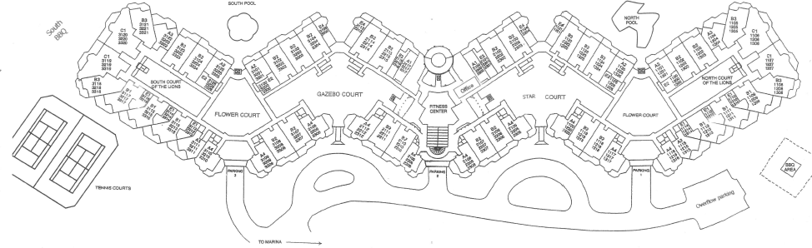

Reservation
I, (print name) _______________________________________________, reserve the following area(s)
for (date) ________/_______/________ from ____:_____ AM/PM to ____:_____ AM/PM
_____North BBQ _____South BBQ _____Wisteria Courtyard
_____Fountain Courtyard ___ Ballroom
The rental fee is $ ___________ times _______ hours
The security deposit is 25% of the rental fee, $_________________ ,and is refundable if the event is cancelled more than 48 hours prior to the scheduled event or the area(s) have been completed cleaned up after the event.

I understand that table and chairs are not include in the rental fee for outdoors areas.
I understand that I am responsible for all setup and tear down, as well as cleaning.
I understand that I am responsible for any damage to the property done by anyone participating in the event.
I understand all participants must abide by Island rules and general courtesy. If the police needs to be called, I will forfeit the deposit.
I understand the board must approve this request.

________________________________ ________________________________ ______
Print responsible party’s name Responsible party signature Date

_ _ _ _ _ _ _ _ _ _ _ _ _
OFFICE USE ONLY
Date sent to the Board____________
Decision of the Board ____Approved _____Approved with modifications _____Denied
Date Requestor notified ___________

